Evaporator-Rotary
Principle :
Rotary Evaporator also known as Rotary Film Evaporator or Rotary Vacuum film Evaporator is essentially thin Film Evaporator
Thin Film Evaporator is used for Concentration of Heat sensitive materials by gentle evaporation such as Phospholypids,Enzyme ,Orange juice .Different evaporator can be employed depending on viscosities like Rotary Film Evaporator-Wiped Film Evaporator –Falling Film Evaporator-Rising Film Evaporator
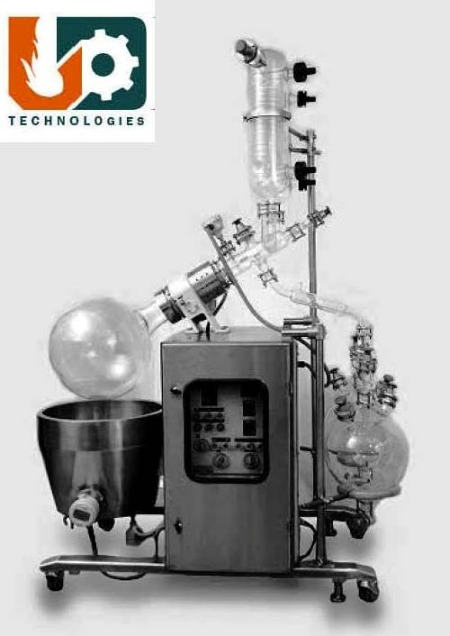
The rotary evaporator principle is the most universal method, as it is an efficient, last and gentle way to separate liquids. The rotating flask continuously covers a large surface area with a thin film due to Rotary motion, which is ideal for rapid heat transfer. Fortuitously, the film also ensures uniform heat distribution without local heating.
The facility to work the unit under full vacuum further facilitates evaporation at as low temperature as possible. These features renders rotary film evaporator to be ideally suited for evaporation of heat sensitive Materials

SALIENT FEATURES:
Rotary Evaporators are available in different Options and Models which is to be selected depending on Following Criteria
1. Size-1. Lab Model- 5 liter 2. 20-10-5 Model –(This is multicapacity model in which three sizes 20 Liter-10 liter-5 liter evaporation flasks can be fixed 3.50 liter 4. 100 liter
2. Safety-Flameproof /Non Flameproof Models
3.Validation- GMP –Non GMP
4.Different Automation and control options-Semi Automatic- PC Compatible- Microprocessor controlled
5.Different Glass Distillation assemblies depending on Process requirement
Glass Distillation set up and Equipment can be customized as per applications and process Requirement
6.Different Power Inputs depending on Country’s Voltage systems
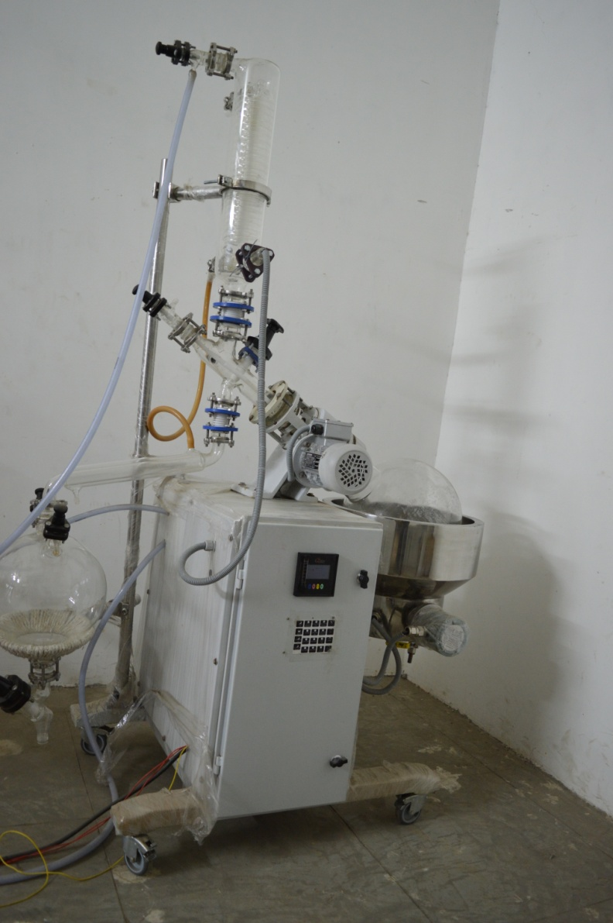
·Salient Fatures
- Best vacuum sealing with Dry Mechnical Seal .All Contact parts are of Glass or/and PTFE ,which extends its life and reduces down time
- Special arrangement is provided such that single person can dismantle hot flask safely
- Operator Friendly control panel
- Combo models are available for Solid Liquid Extraction and Concentration
· Please send us your requirements on srshah@udtechnologies.com and
+91-7990397491(Whatsapp)

